Commodore PET/CBM80xx/40xx A/V-Interface **Rev. 2**

**Testing**

# Test Setup

## Computers

* Commodore CBM3016
* Commodore CBM8032

## Video Equipment

* Monitor/Samsung smart TV
* Micomsoft Framemeister XRGB-mini (Video to HDMI converter)
* RetroTINK x2
* TFT display and converter board

## Device Under Test

* PET A/V-Interface Rev. 2, power option: box connector
* Cassette Port Dongle (from [C64 Diagnostic Harness](https://github.com/svenpetersen1965/C64-Diagnostic-Rev.-586220-Harness/tree/master/Diag586220_Harness/Diag586220_Cassette_Port)) and ribbon cable.

## Other

* [PET Diagnostic Clip](https://github.com/svenpetersen1965/PET-Diagnostic-Clip)
* TFW8bit SD2PET Future (Floppy disk emulator)
* 5m audio/video cable for composite video

# Test Execution

## CBM3016

The PET A/V-Interface was connected to the CBM3016. The Cassette Dongle was and the ribbon cable for providing +5V to the interface was installed. The switch SW3 on the interface is set to “NON INV” (non-inverted).

An A/V cable was used to connect the interface to the Framemeister. The CBM3016 was powered up and the screen content appeared on the monitor.

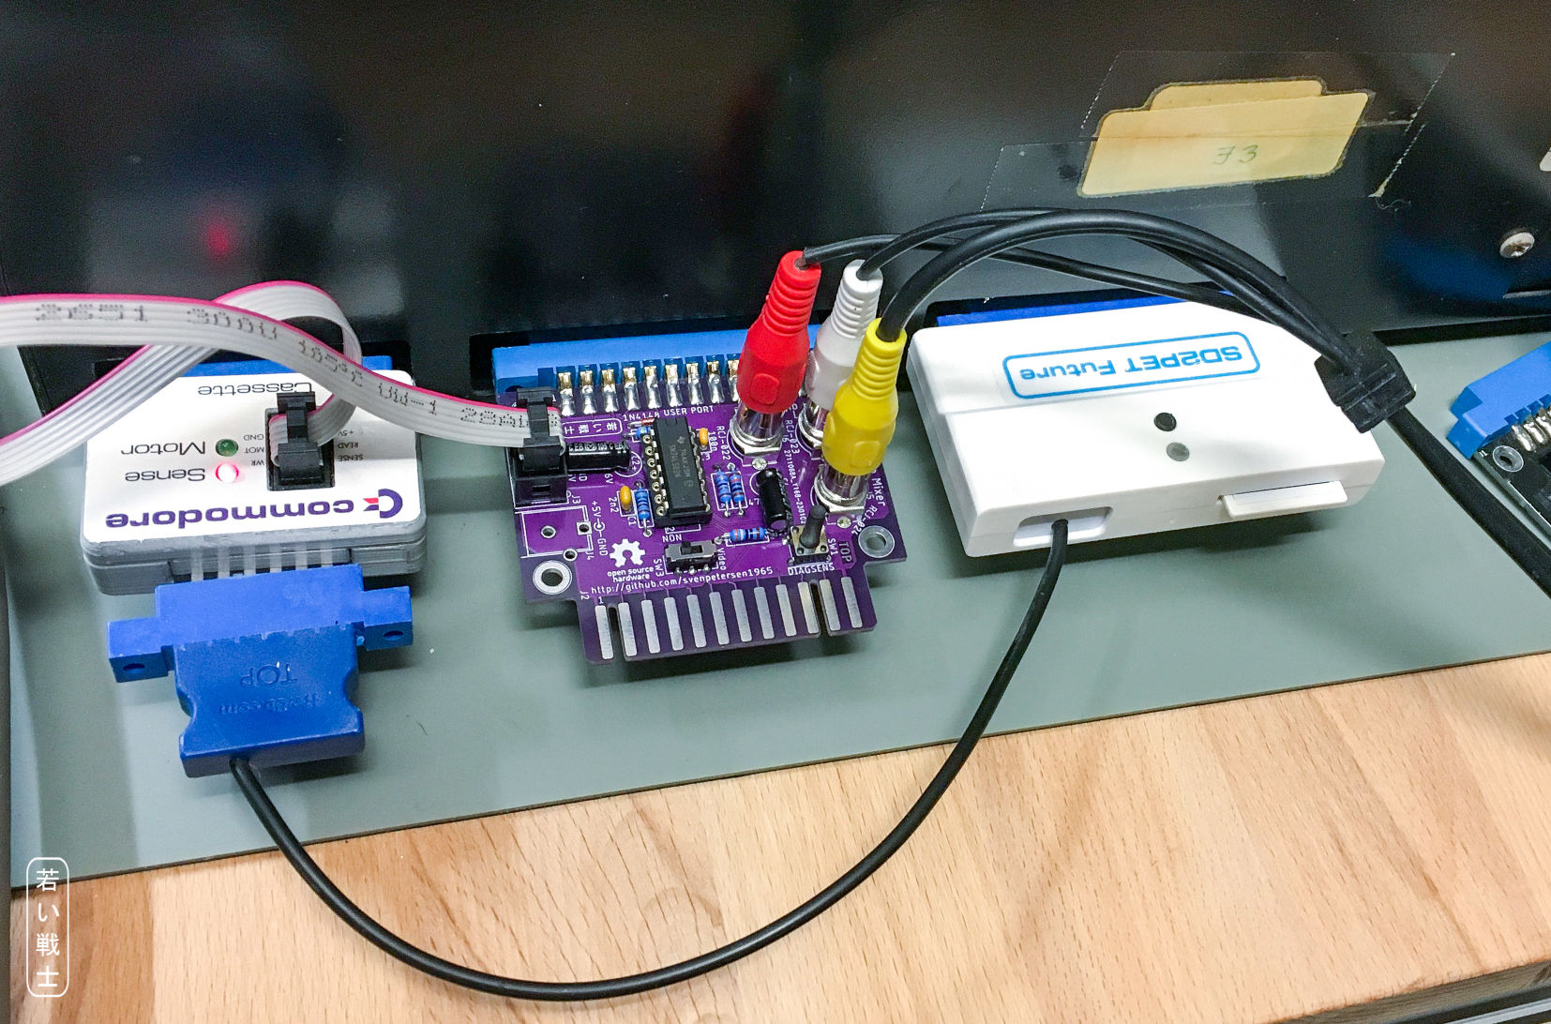

Figure 1: PET A/V Interface on CBM3016, powered from Cassette port (and SD2PET Future Floppy Disk emulator)

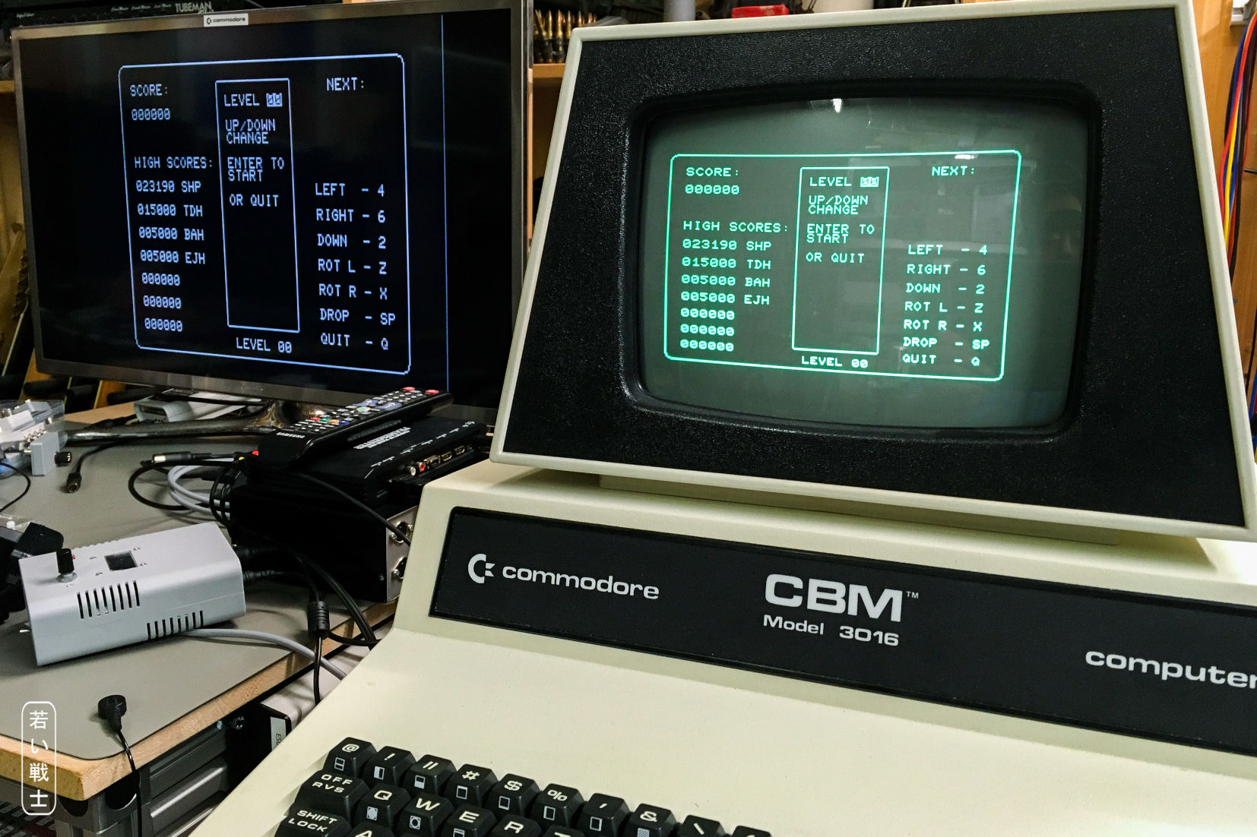

Figure 2: CBM3016 monitor and video output on a Framemeister HDMI adapter

A game software was loaded from the SD2PET Future and run. The sounds of the game became audible.

## CBM8032

The switch SW3 was set to “INV” (inverted). To prevent modifying the Edit ROM of the 8032, the 80 col diagnostic software of the [Diagnostic Clip](https://github.com/svenpetersen1965/PET-Diagnostic-Clip) was modified. That means, the parameters for an NTSC output of the CRTC were replaced in that software.

$025B $3F $28 $32 $12 $1E $06 $19 $1C $00 $07 $00 $00 $10 $00 $00 $00 $00 $00

At the offset address of $025B, the data shown above is replacing the original data. This if the data set labeled “40/80x25, 60 Hz, 15.748 kHz (NTSC) for External Monitor (inverted video)” from Steve Gray’s file “[cbm-edit-rom/crtc-reg-normal.asm](https://github.com/sjgray/cbm-edit-rom/blob/master/crtc-reg-normal.asm)”

The BIN-file was burned into an EPROM, which was then installed in the PET Diagnostic Clip. The clip was then installed in the CBM8032. This was then switched on and the Diagnostic Start screen was displayed (Figure 3).

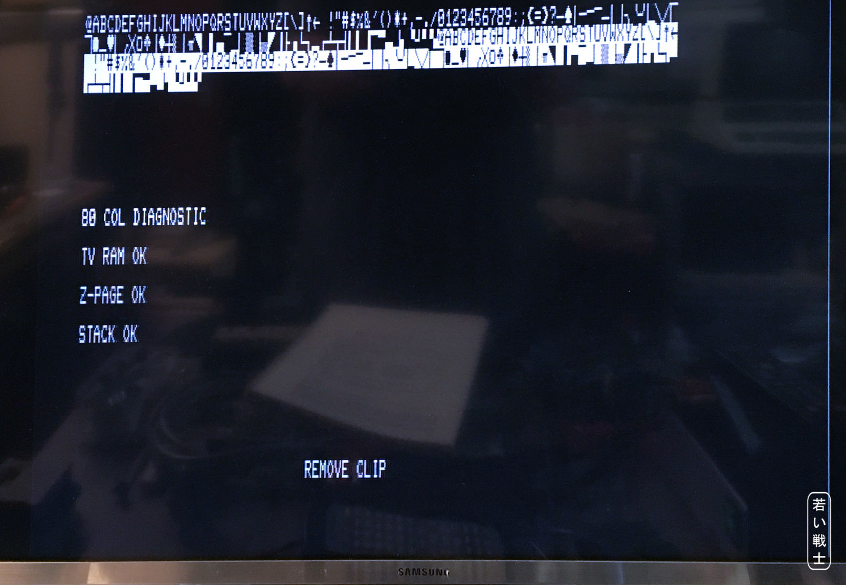

Figure 3: Output of a CRTC machine with edited parameters for NTSC output (the diagnostic clip software)

Note: for completing the Diagnostic Test, the new timing parameters would require to be modified in the test software as well. Without this, the diagnostic test will wail with a horizontal timing error (Figure 4).

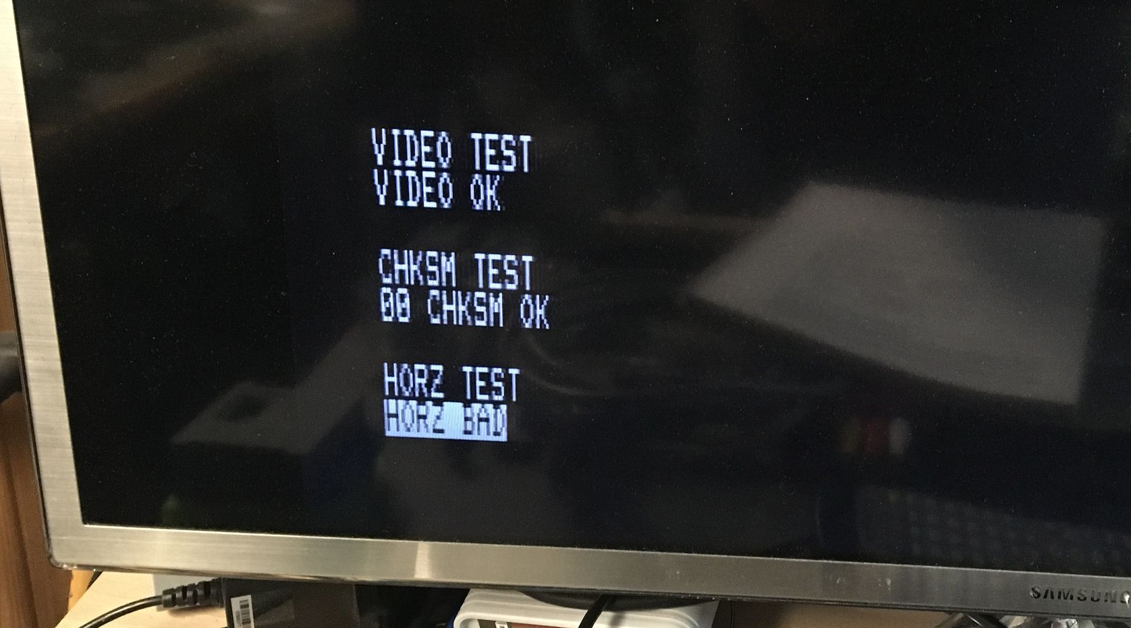

Figure 4: Error message of the modified 80col diagnostic software

Further, the internal monitor produced an unusual sound and did not sync. It is not recommended to drive the complete with this set of parameters.

# Conclusion

The PET A/V interface works with non CRTC and with CRTC machines.

The required parameter-change for the CRTC machines and the fact, that the internal monitor does not synchronize with the said settings reduces the usability of the A/V interface for this kind of computers to probably only repair purposes.

**The PET A/V-Adapter Rev. 2 is fully functional.**